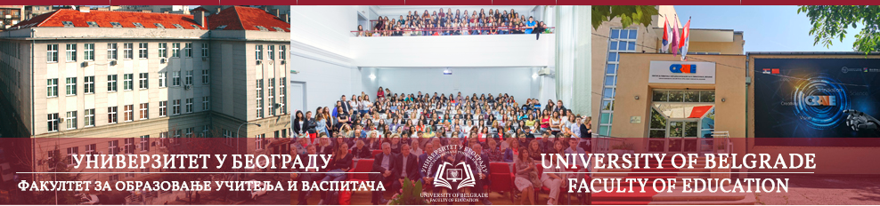

Call for papers

International scientific conference

SCIENCE, LANGUAGE AND CULTURE IN EDUCATION

Faculty of Education, University of Belgrade
Belgrade, 31 May 2025

Dear colleagues,
The Faculty of Education of the University of Belgrade is organising an international scientific conference entitled “Science, language and culture in education”, to be held on 31 May 2025. We invite participants from different areas of expertise to share their research results and experience, and exchange opinions on the challenges and perspectives of education in modern society. Hoping some of the topics below will inspire you to contribute, we invite you to participate in our conference with a presentation.
Conference tracks:
1. Ecological identity and education
2. Educational digital technology in scientific, linguistic and cultural development
3. Artificial intelligence in education
4. Contributions of didactics and teaching methodologies to cultural and identity development
5. Physical activity in modern education
6. Mathematical literacy in modern education
7. Productive mathematical discussions: teaching practices for supporting teachers
8. Challenges of the teaching profession in modern society
9. Family and educational institutions partnerships for the benefit of children/students
10. Visual language in education
11. The role of music in children’s linguistic expression and identity development
12. National identity, multiculturalism and interculturalism in the development of science, language and culture
13. Multilingual competencies in modern education
14. Language for specific purposes – a necessary element in building professional identity
15. Teaching language and literature: cultural competence and aspects of identity
16. “National” and “the other” subjects: cultural policy in modern world educational curricula

Papers outside the given thematic framework are also welcome providing they correspond to the main conference theme.
The speaker proposal form with the presentation title and an abstract in Serbian and English, or in English only, should be submitted by 15 February 2025, to the following e-mail address: naucni.skup2025@uf.bg.ac.rs. The application form is available at the Conference website: naucniskup.uf.bg.ac.rs.
Note: The abstract in English must be professionally translated/proofread prior to submission. By sending in the speaker proposal form, the author guarantees for the abstract language quality.
The abstract should contain a brief description of the presentation content: the context and relevance of the topic, the aim of research, scientific methods applied, as well as the most relevant findings and conclusions. The abstract should not exceed 1400 characters (with spaces). The mentioned structure is not binding for theoretical paper abstracts.
Conference languages: Serbian and English.
Deadline for notification of abstract acceptance: 1 April 2025. The deadline for the full paper submission in English or Serbian is 15 September 2025. Following a double-blind peer review, the selected papers will be published in the Book of Proceedings.
The conference will be held in a hybrid format: live and online. The conference fee for participating in person is 8 400,00 dinars for participants from Serbia, or 70 euros for participants from abroad. The conference fee covers conference organisation expenses, conference materials for participants (promotional material, conference programme, e-book of abstracts, Book of Proceedings, certificate, etc.), cocktail-lunch, coffee and drinks in breaks between sessions. The fee for online attendance is 6 000,00 dinars for participants from Serbia, or 50 euros for participants from abroad. It covers the expenses of conference organisation and the participants will receive an e-book of abstracts, conference programme, the Certificate of Participation and the e-book of proceedings. Payment instructions are available at naucniskup.uf.bg.ac.rs, in the folder Instructions for authors.
The deadline for the conference payment is 15 May 2025.
We kindly ask you to forward this invitation to your colleagues who may be interested in participating in the conference.
For any additional information, please contact Ivana Marković, president of the Organising Committee at naucni.skup2025@uf.bg.ac.rs.

We look forward to seeing you at the conference.
Sincerely,
Dean of the Faculty of Education, Presidents of the Programme Committee,
Danimir Mandić, PhD, Full Professor Ana Vujović, PhD, Full Professor
Nataša Janković, PhD, Associate Professor

