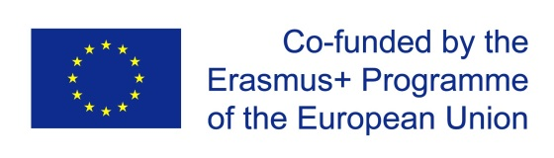

LEARNING, TEACHING AND TRAINING ACTIVITY in Ljubljana

„Programme for professional capacity development for Early Childhood Education and Care “

No. of the Project: 2020-1-SK01-KA201-078304
Date: 22nd – 26th May 2023
Meeting venue: Faculty of Education, Kardeljeva ploščad 16, Ljubljana

Monday | 22nd May 2023 | Details
 | Arrivals

Tuesday | 23rd May 2023 | Details/Address
8:00 | Faculty of Education  - Preschool education in Slovenia and Curriculum for Kindergartens | Kardeljeva ploščad 16, Ljubljana
9:30-9:45 | Coffee break
9:45-12:00 | Faculty of Education  - Learning and teaching through artistic experience
12:00-13:00 | Lunch break | Faculty of Education
13:00-15:00 | Faculty of Education  - Education and training for sustainable development and green transition
 | Free programme

Wednesday | 24th May 2023 | Details/Address
8:00 | Faculty of Education  - Practical pedagogical training | Kardeljeva ploščad 16, Ljubljana
9:30-9:45 | Coffee break
9:45-12:00 | Faculty of Education  - Children’s participation and listening in kindergarten
12:00-13.00 | Lunch break | Faculty of Education
13:00-15:00 | Faculty of Education  - Word and art: wordless picture book  - Mathematical and artistic: mathematical picture book
15:00- | Free programme

Thursday | 25th May 2023 | Details/Address
8:00 | Kindergarten Ciciban | Šarhova 29, Ljubljana (car, bus)
- Information about the Kindergarten Ciciban.
- Visiting preschool classrooms.
- Kindergarten and staff rooms.
- Daily routine.
- Activities in different areas of the curriculum.
- Teamwork in the kindergarten.
- Relationships between children, between children and adults in kindergarten, social learning.
12:00 | Lunch at the Faculty of Education | Kardeljeva ploščad 16, Ljubljana
14:00-15.30 | Faculty of Education  - Discussions.
15.30- | Free programme

Friday | 26th May 2023 | Details
 | Departures

Contact:
Darija Skubic
darija.skubic@pef.uni-lj.si

