INSTRUCTIONS FOR CONVERTING WORD (.DOC) DOCUMENTS TO PDF (.PDF) FORMAT

In order to convert a document in Word format (doc.) into Adobe format (.pdf), a programme needs to be installed that will enable conversion. In more recent versions of Microsoft Office, the PDF conversion option can be already defaulted (in the form of a document editing tab or when choosing a printer), otherwise, a PDF converter must be installed. There are many such programmes available, of which some are also free of charge, and they are easy to use. One of them is the CutePDF Writer programme, which is available at http://www.cutepdf.com/Products/CutePDF/writer.asp .

Installation

On the main CutePDF Writer website, there are two links to the programme on the left, which are needed to write the document in PDF format: Free Download (CutePDF Writer) and Free Converter.

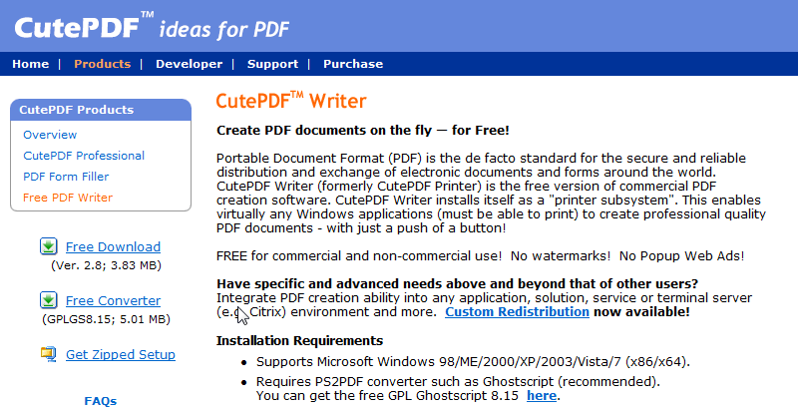

Click on each link separately and install both programmes; first, save the file, then run it. Installation procedure:
1.

2.
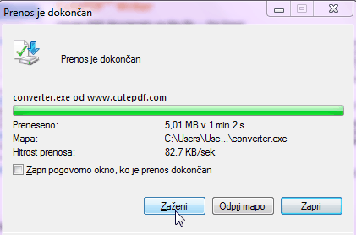

Conversion into PDF

When the PDF converter is installed, select the "Print" command (as with document printing) in the currently open Word document to perform conversion, and select the CutePDF Writer printer. Refer the document to "Print".

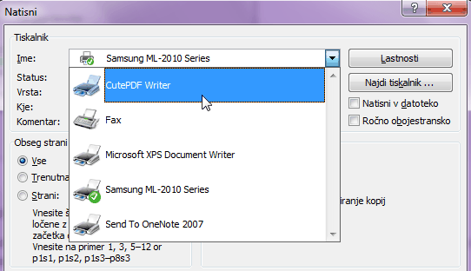

The document is converted and saved in PDF format.

